Restaurant Management System

**PROBLEM STATEMENT**

In this project our goal is to create a Restaurant Management System for “Booking Food Online”, “Reserving Halls for Party or Private Dining Rooms and Meeting halls for various reasons” and “Viewing menus in restaurant and adding reviews for all that functions you perform in or within the system including online reservation and online ordering of food”.

**Description Overview:**

* **Restaurant management refers to managing day-to-day operations within a restaurant or similar setting. It encompasses various tasks and responsibilities, from overseeing company finances and facilitating business growth to overseeing marketing, managing the workforce, and delivering a great customer experience.**
* **A restaurant management system is a type of software that has been specifically designed for use within the restaurant industry. Also known as restaurant management software, such solutions are intended to assist leaders and others in carrying out the most critical managerial tasks.**
* **A system of this type may be a comprehensive all-in-one solution, including elements of a point-of-sale system, such as payment processing, with more complex back-end features, such as workforce management, inventory management, and a booking or reservations system. However, some restaurant management systems focus on specific areas.**

**The project includes:**

1. **Offline booking which allows users to dive in and book their menu and food of their choice also giving reviews to improve the management working.**
2. **Online ordering of food which allows users to select the app to order food, select the food they want to order, see the time needed to prepare food and deliver it to the specified address with shipping charges added to an amount of certain booking and view the different types of payment options available.**
3. **Reservation of table or halls pre-hand to avoid log in later applications, based upon certain criteria such as date, occasion, theme, number of people arriving and total amount calculated with different payment options.**

**Technology used:**

Here we will be using **Visual Studio Code or Jupyter Lab platform** to code our programwith the use of different python functions to perform the operations needed to achieve the above mentioned tasks or operations to be achieved.(Backend)

Flask operator with different templates has been used to create the front end with various HTML operators.

We have used MySQL Database to store the information.

**INSTALLATION:**

Installation of this project is pretty easy. Please do follow the following steps to create a virtual environment and perform the following functions according to your needs.

**In Jupyter Lab it’s easy:**

1. **Install Jupyter Lab on your system using the command “pip install jupyterlab” .**
2. **Then click on new and select “Python3 (ipby kernel)”.**
3. **Using your programming skills start creating your project.**

**In Visual Studio Code it’s easy:**

1. **Download and Install Visual Studio Code**:
   * If you haven’t already, download and install [Visual Studio Code](https://code.visualstudio.com/download).
2. **Open a Folder in VS Code**:
   * Launch VS Code.
   * Open a folder by going to **File > Open Folder** (or use the shortcut **Ctrl+K Ctrl+O**).
   * This folder will be the workspace for your project.
3. **Create a New File**:
   * To create a new file, go to **File > New File** (shortcut: **Cmd+N** or **Ctrl+N**).
   * Save the file using **File > Save** (shortcut: **Cmd+S** or **Ctrl+S**).
4. **Install Extensions**:
   * Explore the Extensions view (**View > Extensions**) to find and install extensions relevant to your project (e.g., Python, JavaScript, etc.).
5. **Start Debugging**:
   * To run your code, select **Run > Start Debugging** (shortcut: **F5**).
   * Configure your launch settings in the .vscode/launch.json file.

**Workflow for RMS:**

**Offline Ordering:**

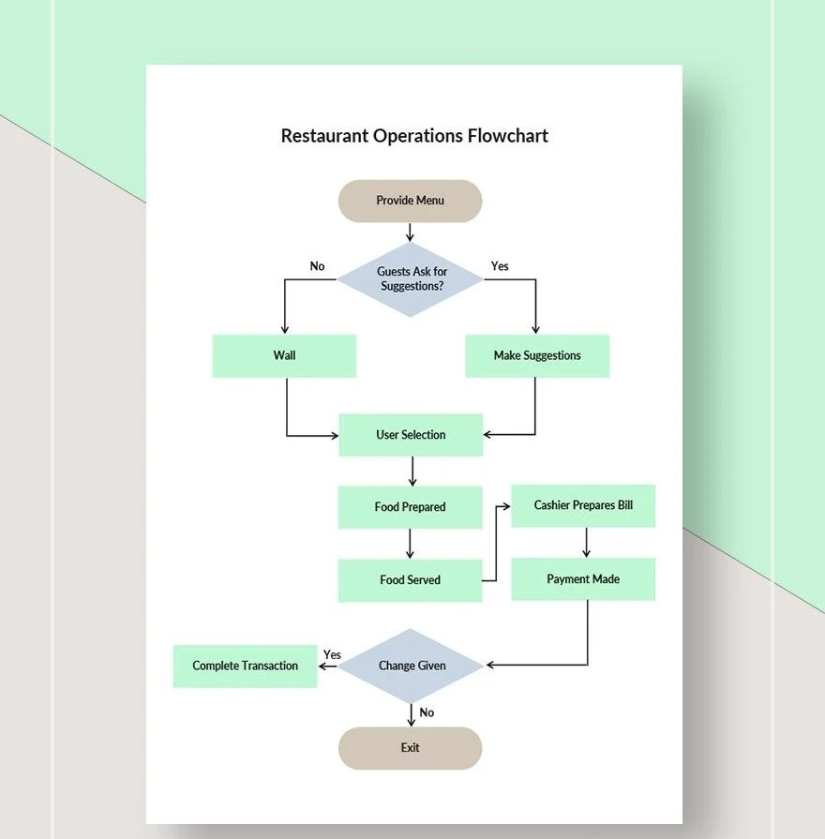

**Online Ordering:**

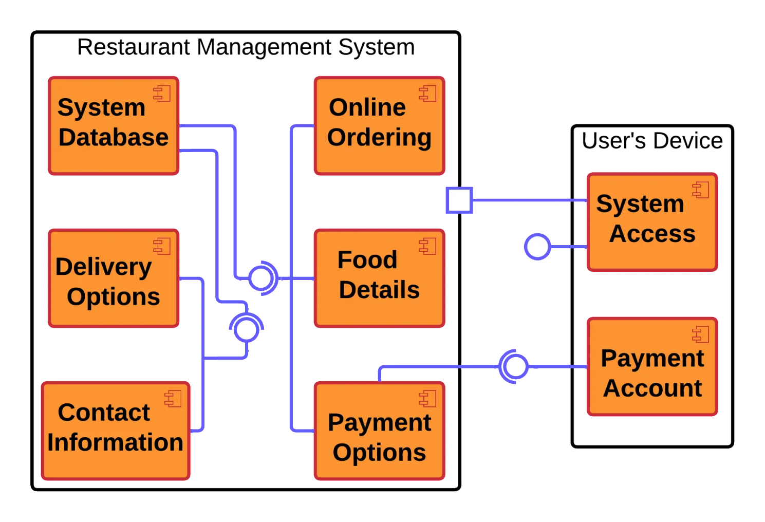

**Hall Reservation:**

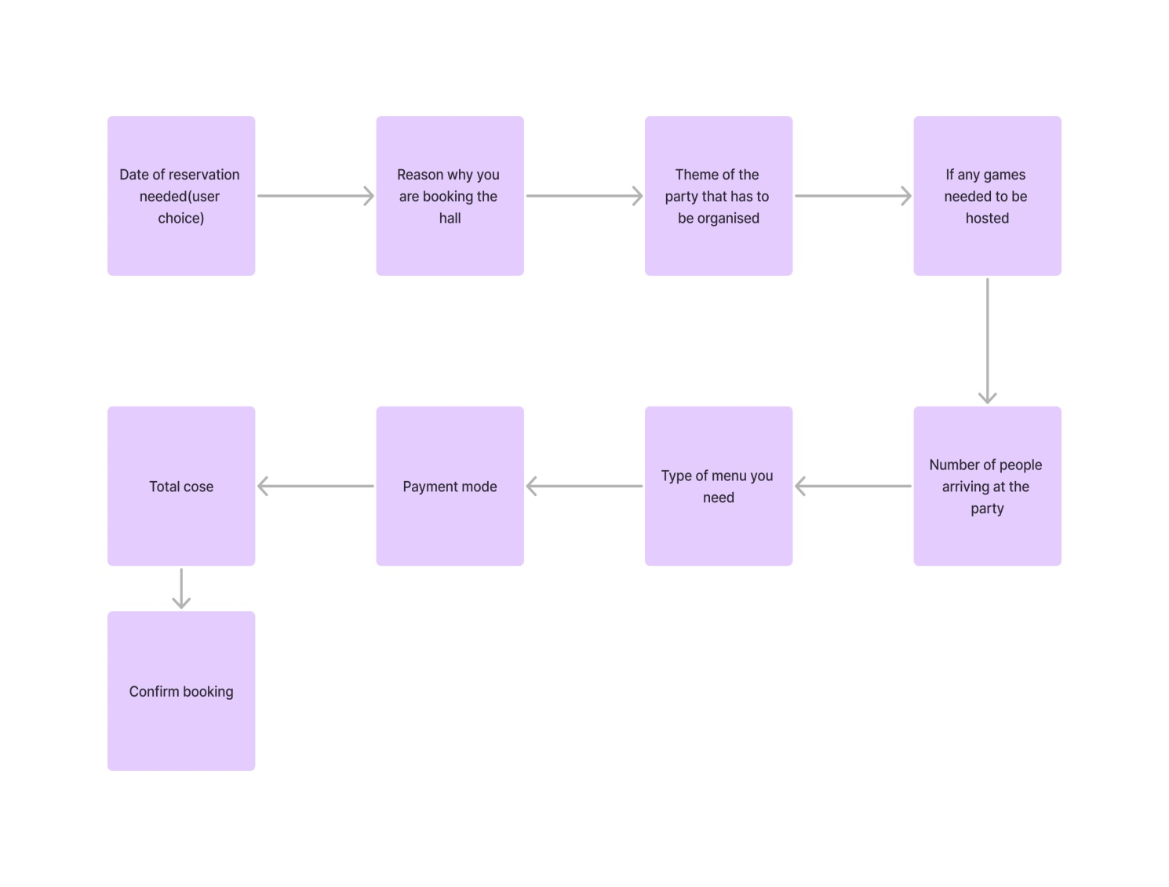

**Implementation:**

1. **Project Directory:**

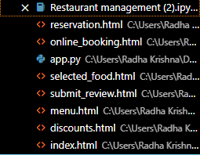

1. **Backend:**

**The code has been stored the following file.**



1. **Database Used:**

**The database that has been used to store our project is MySQL. The following file consists of the database and its format.**



1. **Frontend:**

**The front end has been created using Visual Studio Code application with various HTML tags, Flask Operator and connecting the backend code to the frontend allowing users to only access the application without knowing the actual processes that are going on.**

* **Offline ordering:**



**This contains the coding part of offline orders placed by various customers.**

* **Online Ordering:**



**This contains the coding part of online orders placed by various customers.**

* **Reservation for party hall:**



**This contains the coding part of reserving a hall for party pre hand.**

**All the files, templates and other HTML codes that are linked to each other will be added at my git hub account with the folder.**

**Testing the program code:**

To run this project in your local system just run the file Restaurant Management.py and the result will be obtained.

* Offline Ordering:

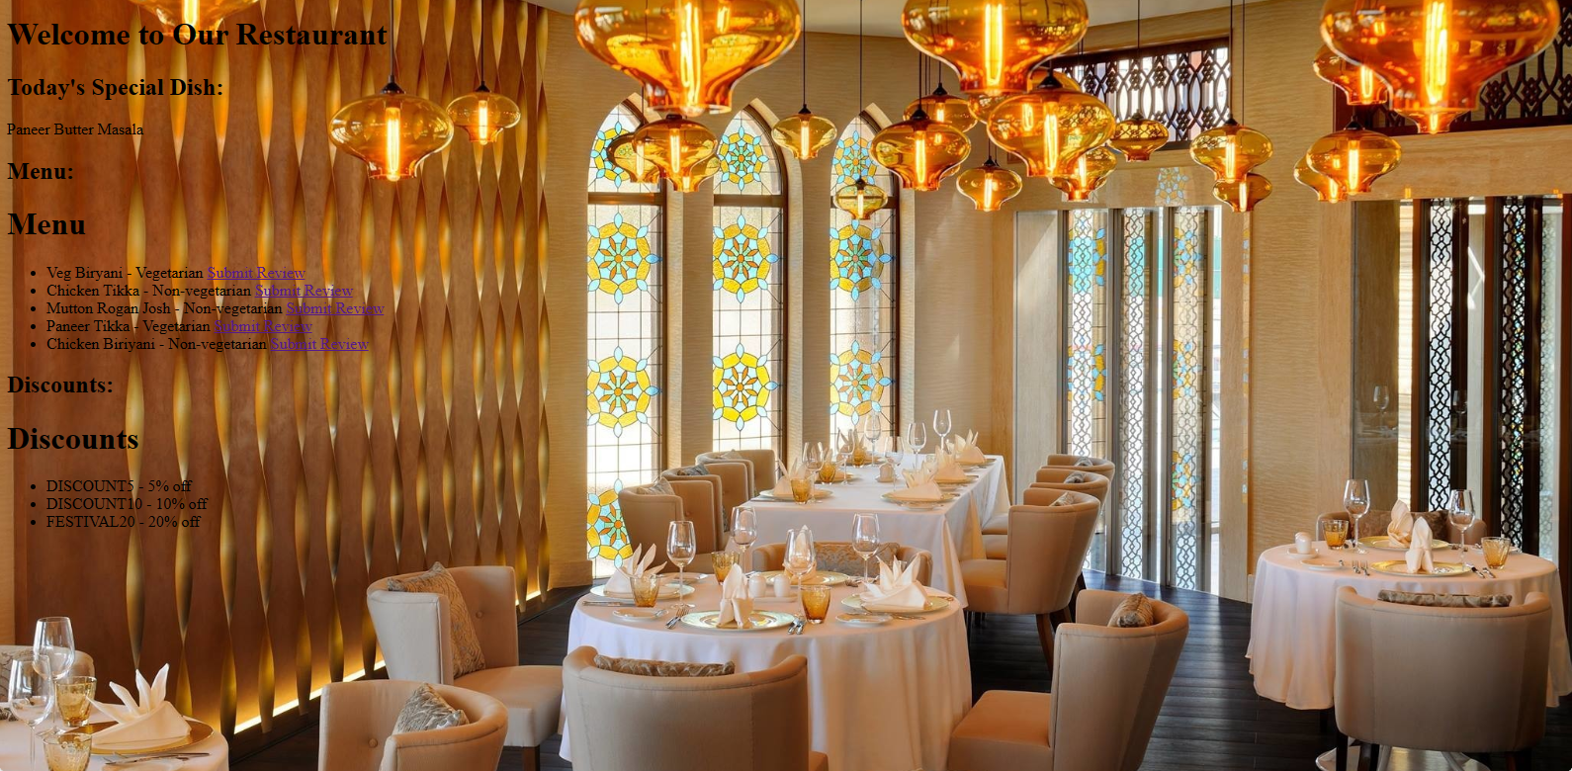

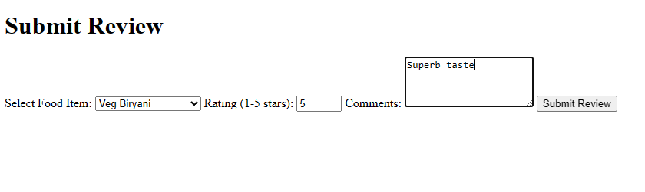

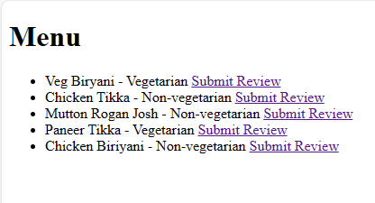

* **Online Ordering:**

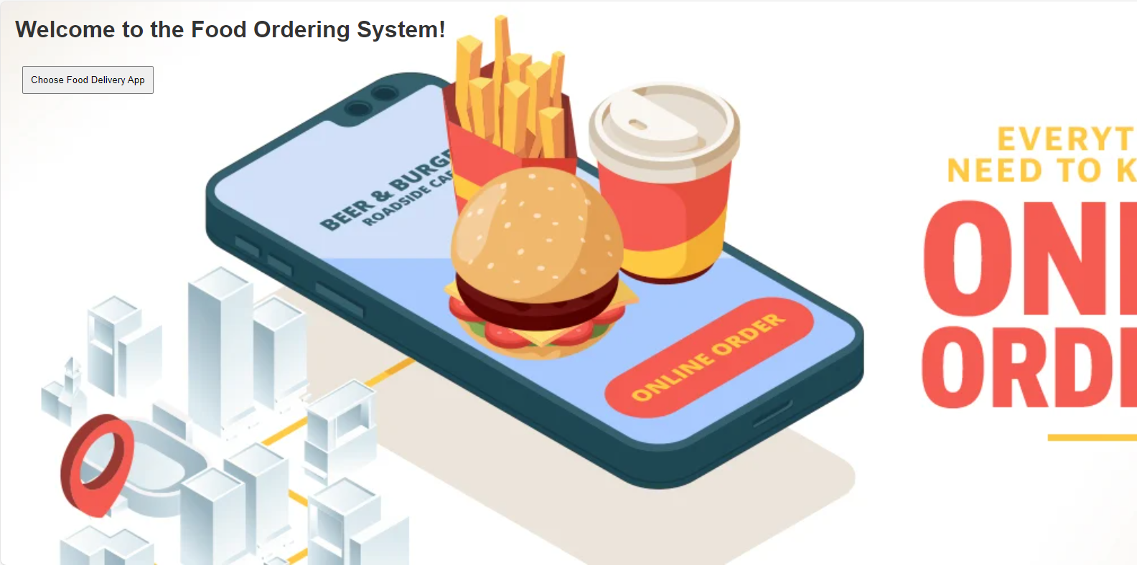

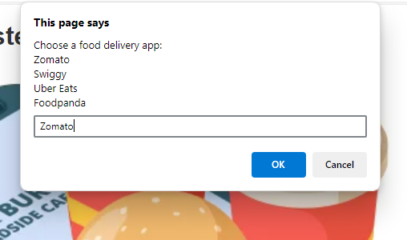

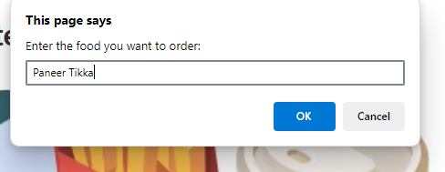

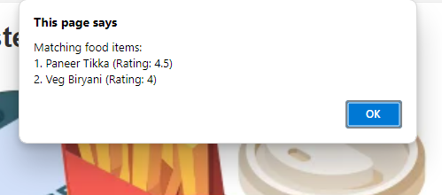

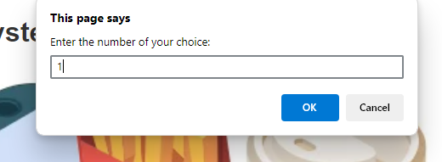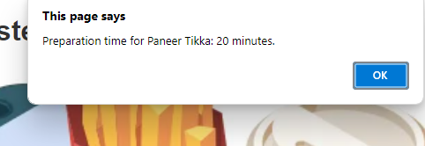

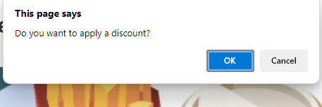

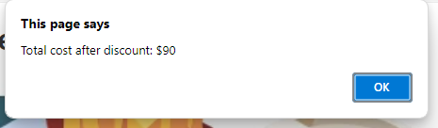

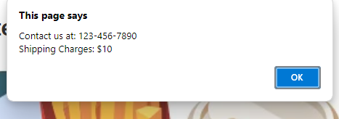

* **Party Hall Reservation:**

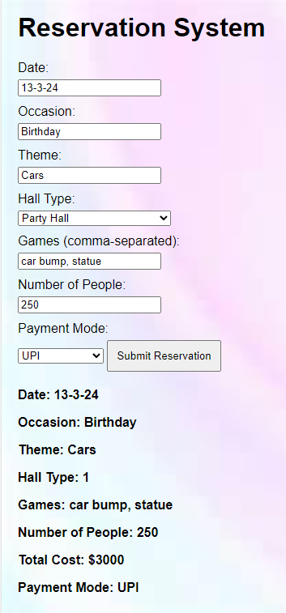

**Conclusion:**

**We have seen how a RMS (Restaurant Managemnt System Work) and how food has been booked online, ordered offline and how reservations are made for party according to your schedule.**

**Comparison:**

**We have developed a platform that is different from all other Restaurant Management Systems including many more features that aren’t available in older system or the existing systems.**